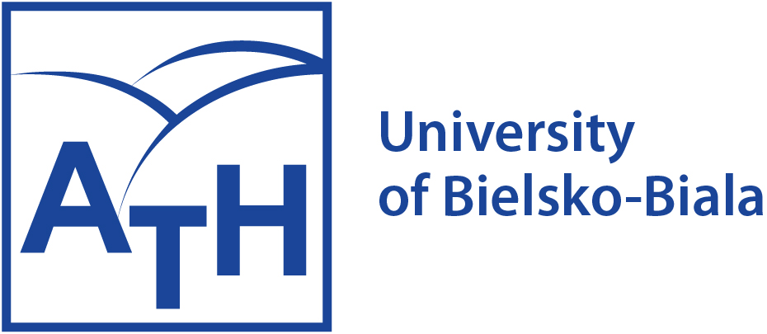 INCLUDEPICTURE "https://www.eng.ath.bielsko.pl/images/EU-flag-Erasmus_vect_POS.jpg" \* MERGEFORMATINET INCLUDEPICTURE "https://www.eng.ath.bielsko.pl/images/EU-flag-Erasmus_vect_POS.jpg" \* MERGEFORMATINET 

LETTER OF INVITATION

This letter confirms the Erasmus+ Exchange Program for Staff between the (Insert University), (Insert Country) and the University of Bielsko-Biala, Poland. As a part of this program, we kindly invite (Name and academic title) to spend the period from (day/month/year) to (day/month/year) in the Faculty of (Insert Faculty), giving (insert hours) hours of lectures.

We would like to mention that this invitation remains available only in the case of having classes at the University of Bielsko-Biala, Poland in the face-to-face scenario during the above-mentioned period. This invitation does not include any funding for your subsistence, medical insurance or salary from our university. This letter confirms that the Erasmus+ Exchange Program Bilateral Agreement is valid for the purpose of acquiring a visa to cover your stay in Poland. We will be happy to host you at our university, and we are looking forward to working with you.

Bielsko-Biala, (day/month/year)

address: ul. Willowa 2, 43-309 Bielsko-Biała, Poland

e-mail: international@ath.bielsko.pl

